Trong muc Controller add 1 controller: chon API Controller

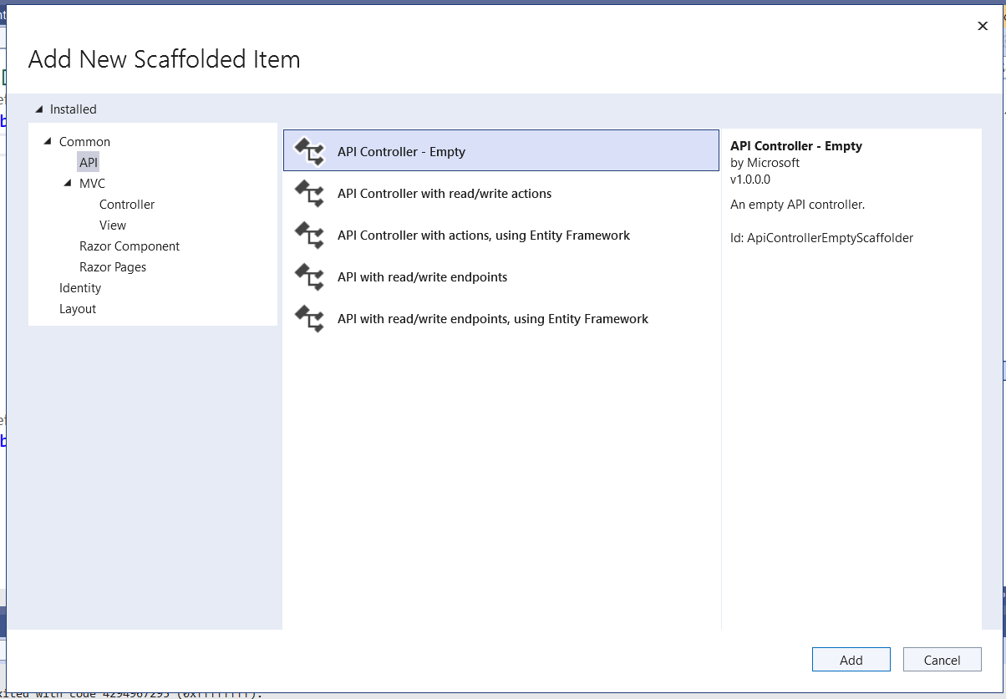

Them: using Ogani.Models;

namespace Ogani.Controllers

{

[Route("api/[controller]")]

[ApiController]

public class ProductAPIController : ControllerBase

{

QlbanVaLiContext csdl = new QlbanVaLiContext();

[HttpGet]

public IEnumerable<TDanhMucSp> GetAllProduct()

{

return csdl.TDanhMucSps.ToList();

}

}

}

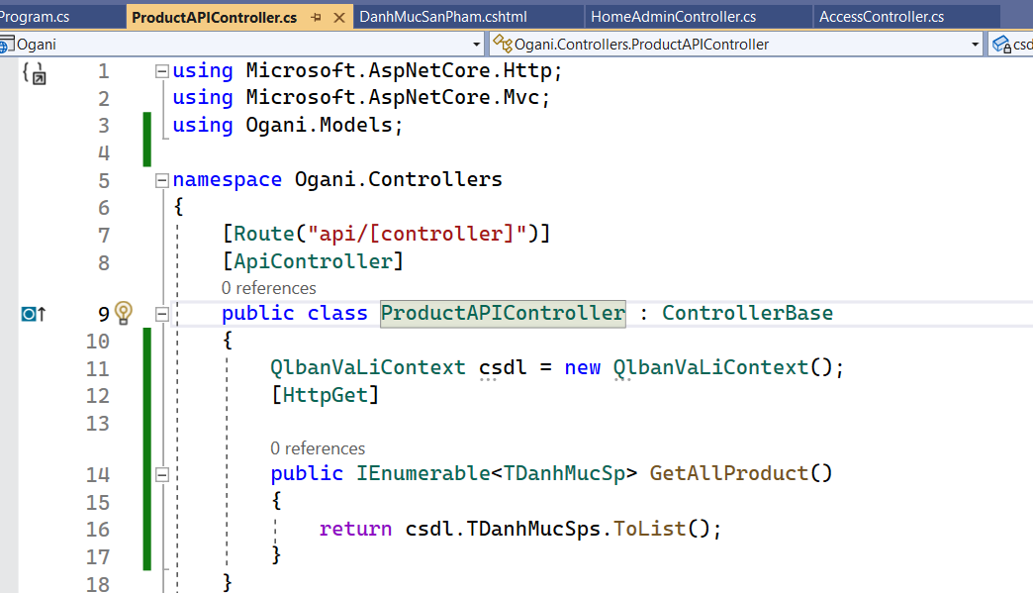

De chay thu duoc Web api thi vao Program.cs sua lai link

pattern: "{controller=Home}/{action=Index}/{id?}");

Khi chay thi them /api/productapi

Trong Model them 1 folder ProductModels -> add class Product:

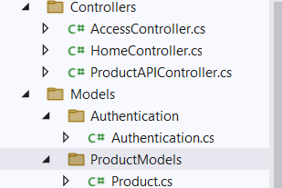

public class Product

{

public string MaSp { get; set; }

public string? TenSp { get; set; }

public string? MaLoai { get; set; }

public string? AnhDaiDien { get; set; }

public decimal? GiaNhoNhat { get; set; }

}

Sang ben ProductAPIController: sua doan code nay:

public IEnumerable<Product> GetAllProduct()

{

var sanpham = (from p in csdl.TDanhMucSps select new Product

{

MaSp = p.MaSp,

TenSp = p.TenSp,

MaLoai = p.MaLoai,

AnhDaiDien = p.AnhDaiDien,

GiaNhoNhat = p.GiaNhoNhat

}).ToList();

return sanpham;

}

Lay san pham theo loai:

[HttpGet("{maloai}")]

public IEnumerable<Product> GetProductsByCategory(string maloai)

{

var sanpham = (from p in csdl.TDanhMucSps

where p.MaLoai==maloai

select new Product

{

MaSp = p.MaSp,

TenSp = p.TenSp,

MaLoai = p.MaLoai,

AnhDaiDien = p.AnhDaiDien,

GiaNhoNhat = p.GiaNhoNhat

}).ToList();

return sanpham;

}

Trong file Default:

Them doan code ajax:

<script>

function showProductByCategory(getUrl){

var str = '';

$.ajax({

type: 'GET',

url: getUrl,

dataType: 'json',

success: function(data){

$.each(data, function(key, val){

str += '<p>' + val.tenSp + '</p>'

});

$("#displayProducts").html(str);

},

Error: function(xhr){

alert(xhr.responseText)

}

})

}

</script>

Sua doan code trong foreach:

var getUrl = "https://localhost:7248/api/productapi/" + @item.MaLoai;

<li>

<a style="cursor:pointer" onclick="showProductByCategory('@getUrl')">

@item.Loai</a>

</li>

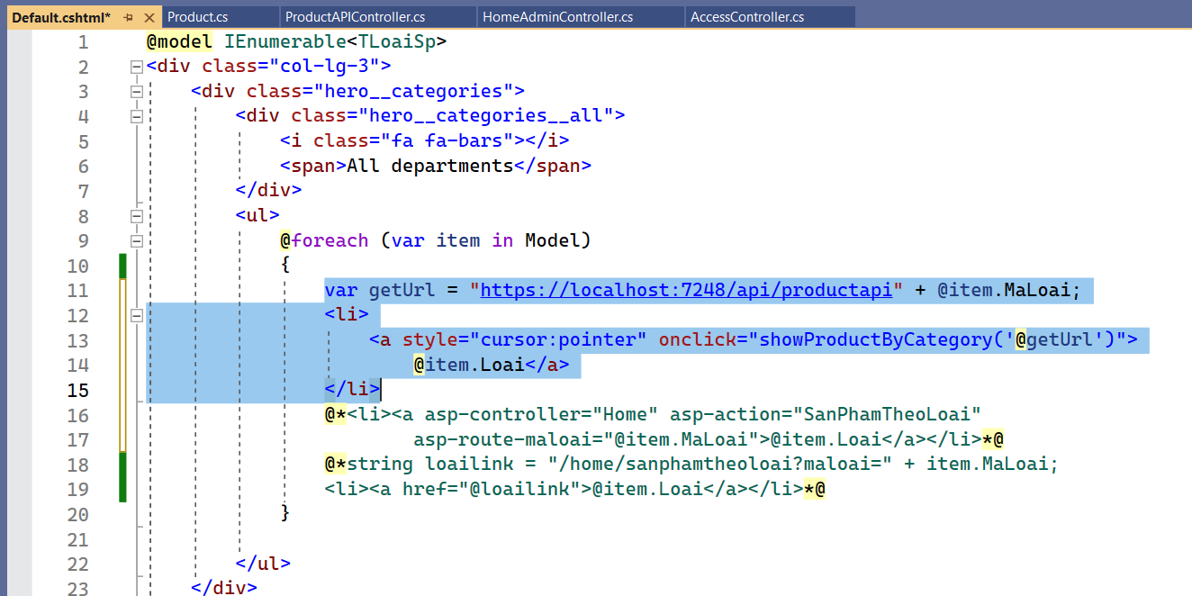

Sang LayoutOgani:

Tim kiem RenderBody()

Them id cho the div: id="displayProducts"

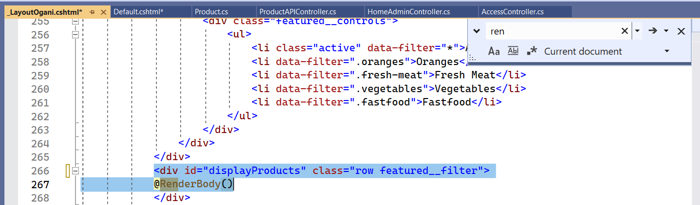

Copy doan code be PartialSanPham sang ben scripts vao doan str += `…`

@Model. -> ${val.}

<script>

function showProductByCategory(getUrl) {

var str = '';

$.ajax({

type: 'GET',

url: getUrl,

dataType: 'json',

error: function (response) {

alert(response.responseText);

},

success: function (data) {

$.each(data, function (key, val) {

str += `<div class="col-lg-3 col-md-4 col-sm-6 mix oranges fresh-meat">

<div class="featured__item">

<div class="featured__item__pic set-bg" data-setbg='../Images/${val.anhDaiDien}'

style="background-image: url('../Images/${val.anhDaiDien}');">

<ul class="featured__item__pic__hover">

<li><a href="#"><i class="fa fa-heart"></i></a></li>

<li><a href="#"><i class="fa fa-retweet"></i></a></li>

<li><a href="#"><i class="fa fa-shopping-cart"></i></a></li>

</ul>

</div>

<div class="featured__item__text">

<h6><a asp-controller="Home" asp-action="ChiTietSanPham" asp-route-MaSp="${val.maSp}">${val.tenSp}</a></h6>

<h5>${val.giaNhoNhat} đồng</h5>

</div>

</div>

</div>`

});

$('#displayProducts').html(str);

},

Error: function(xhr){

alert(xhr.responseText)

}

});

}

</script>